This Form is to be used in Conjunction with MMC-SPE-FORM-001 Major Event Permit Application, (Section 9)

Name of the Event:
Location:
Event Date(s): | Start |  |  | Finish:
Organisation:
Address:
Contact Person: |  |  | Phone Number:
E-mail:

AIM
To clearly define the process to be followed in the event of an emergency situation occurring at the above listed event. The procedures in this plan are guidelines to be used to address any unanticipated emergencies.
This plan will be used as a ‘living document’ to set out the following
- The potential emergencies that may arise
- The written procedures developed in response to the potential emergencies
- The staff members responsible for particular actions in an emergency situation

SCOPE
This plan applies to the above-named Event relating to Emergency Scenarios including (but not limited to):
- Medical emergency
- Fire or Explosion
- Hazardous Material Spill/Gas Leak
- Bomb Threat
- Armed or Dangerous Intruder/s
- Electrical Failure
- Lost Child/Missing Persons

Other more specific emergencies may include:
- _____________________________________
- _____________________________________
- _____________________________________

Training Requirements
All personnel normally working in any of the areas identified in this Emergency Management Plan shall be trained in the following emergency management information:

- The general information contained within this document
- The key personnel and their roles and responsibilities
- Emergency exit locations and paths
- Assembly point locations
- Firefighting equipment locations
- First Aid equipment locations
- Any written procedures applicable to the building/venue regarding Emergency Management

List of Contacts
The following is a list of those staff at the event i.e. Event Permit Holder (Organiser), stallholders, amusement operators and general staff who will be required to take action in the case of an Emergency
INSTRUCTIONS: Highlighted example text can be deleted, typed over as required. Please remove highlight from final information.
Organisation Name | Contact Name | Phone number
ALL Emergency | - | 000
Police | -
Fire | -
Ambulance | -
SA Power Networks | -
Plumber | Name | Phone Number
Electrician | Name | Phone Number
Organisation | Name | Phone Number

Emergency Equipment

Equipment | Location | Other Information
Fire Extinguisher(s)
First Aid Kit(s)
Other

Emergency Team Roles & Responsibilities

Role | Details of responsibilities | Person responsible  (Print Name) | Signature  Sign only when you have read and understood your responsibilities | Details in List of Contacts are correct
Chief Warden | - Attend relevant training.  - Administer first aid support in an emergency situation.  - Supervise and action emergency evacuation procedures (including contacting emergency services, accounting for staff). | Mary Fisher
Warden | - Attend relevant training.  - Assist in evacuating staff according to evacuation procedures (including collecting emergency kit and resilience and recovery documentation).  - Assume Chief Warden duties when required.  - Contact emergency services if required | Fred Flintstone

Emergency Response Procedures
It may be useful to attach a copy of the detailed emergency procedures and floor plan with the location of emergency exits, emergency kit and safety equipment clearly marked. The emergency procedures should also include a map of evacuation locations for all emergencies
Emergency | Procedure | Evacuation Point | Reference
Fire & Explosion | - Raise the Alarm and contact relevant emergency services.  - Chief Warden to evacuate all public to the Emergency Assembly point (EAP).  - Warden If trained and it is safe to do so attempt to extinguish the fire. if unable to do so then to evacuate as per the Evacuation Plan | Name Site  E.g. Shearer Carpark | Attachment  Evacuation Plan
Bomb Threat | - Keep caller talking. Attract committee member to call 000.  - DO NOT HANG UP (call may be traced).  - Write down as much information as possible and record it (Att 2: Bomb Threat Check List)  Follow all instructions given by (name of person elected as being in charge). | Name Site  E.g. Shearer Carpark | Attachment  Bomb Threat Check List
Medical | - Notify the (name of person in charge)  - Assess the situation and provide First Aid if able to do so if unable call Emergency Services – 000 and request and ambulance  - Provide assistance to the injured person until emergency services arrive  - Organise for a staff member to meet the ambulance outside the event and take them to the medical emergency  - Fill in First Aid Report Form and submit to the Event Organiser | Name Site  E.g. Shearer Carpark | Attachment  First Aid Report Form
Hazardous Material Spill/Gas Leak | - Notify the (name of person in charge) immediately  - Chief Warden is to assess the situation and evacuate the event if necessary  - If safe to do so isolate the spill / gas leak  - If necessary contact Emergency Services - 000 | Name Site  E.g. Shearer Carpark | Attachment  Evacuation Plan
Armed or Dangerous Intruder/s | - Contact (name of person in charge) immediately and Security / Police  - Chief Warden is to assess the situation and evacuate the event if necessary  - Follow all directions given by Security / Police | Name Site  E.g. Shearer Carpark | Attachment  Evacuation Plan
Electrical Failure | - Notify the (name of person in charge)  - Arrange emergency lighting where possible  - Chief Warden to assess the situation and evacuate the event if necessary  - Contact SA Power Networks  - Contact electrician  - Close the event if unable to provide adequate emergency lighting. | NA | Attachment  Evacuation Plan
Lost Child / Missing Persons | - Contact (name of person in charge) and advise you have found a lost child or missing person  - Take the lost child/person to the First Aid post as determined in the Risk Control Plan  - Notification of lost child / missing person over the PA system  - Stay with the child/person until appropriate parent/relative/friend has collected  - Advise (name of person in charge) of updated status | N/A | N/A
Unruly Behaviour | - Notify (name of person in charge)  - Notify Security if onsite  - Chief Warden to determine if Police need to be called and call if necessary  - Event staff to diffuse situation if possible or until security/police arrive. | N/A | N/A

Floor Plan / Evacuation Plan

DECLARATION

I acknowledge that I have read and understand the permit conditions and agree to abide by the said conditions, for and on behalf of the event organiser:

Name: |  | Date:
Position: |  | Signature:

FOR OFFICE USE ONLY –
Received by or on behalf of Council:
Name: |  | Date:
Position: |  | Signature:

ATTACHMENT 1 – BOMB THREAT CHECKLIST
(Extract from the Australian Federal Police:
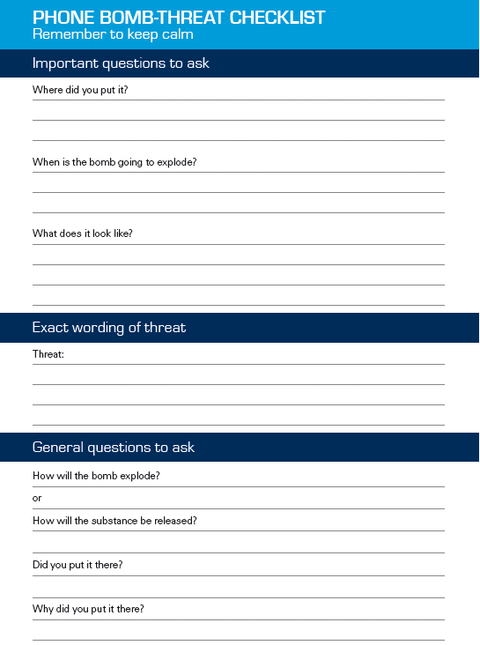

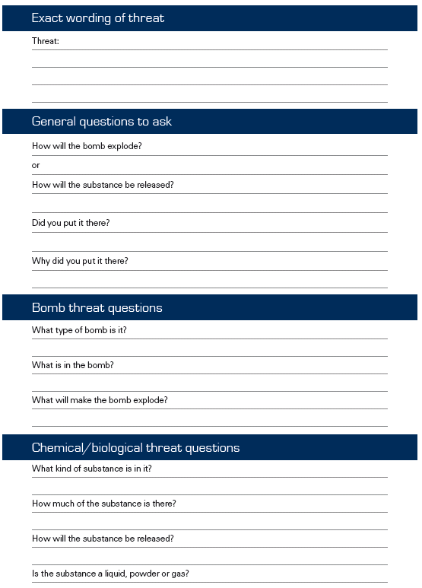

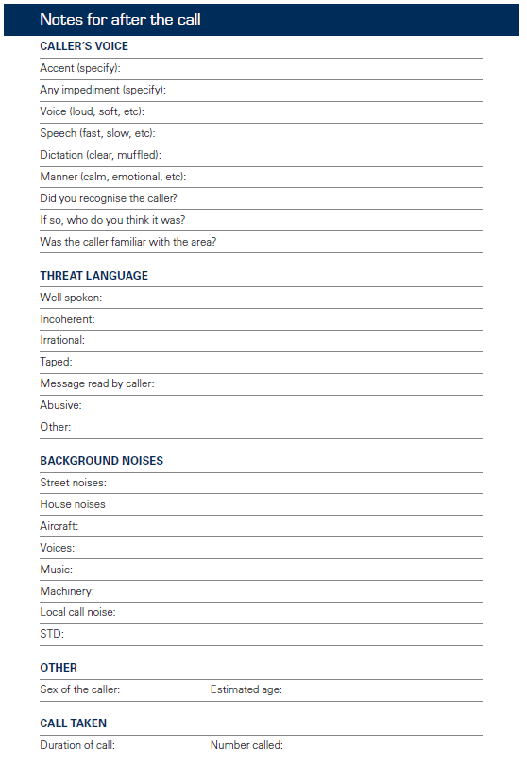

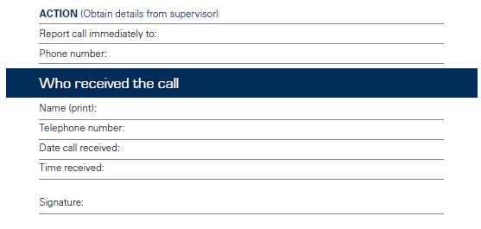

ATTACHMENT 2: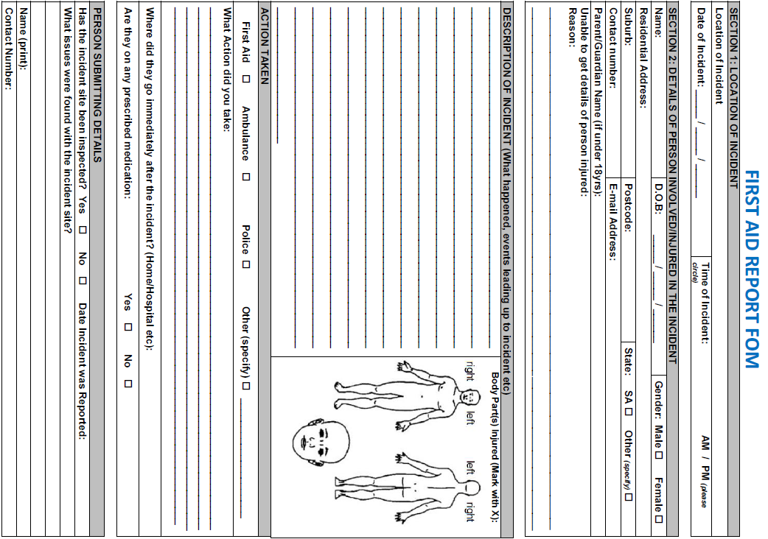

END OF DOCUMENT

